Hello,

Thank you for your interest in my work. I can not wait to collaborate with you for your original piece. Please fill out the form completely. If you have any questions, comments or concerns. Please email fareverart@gmail.com.

Love,
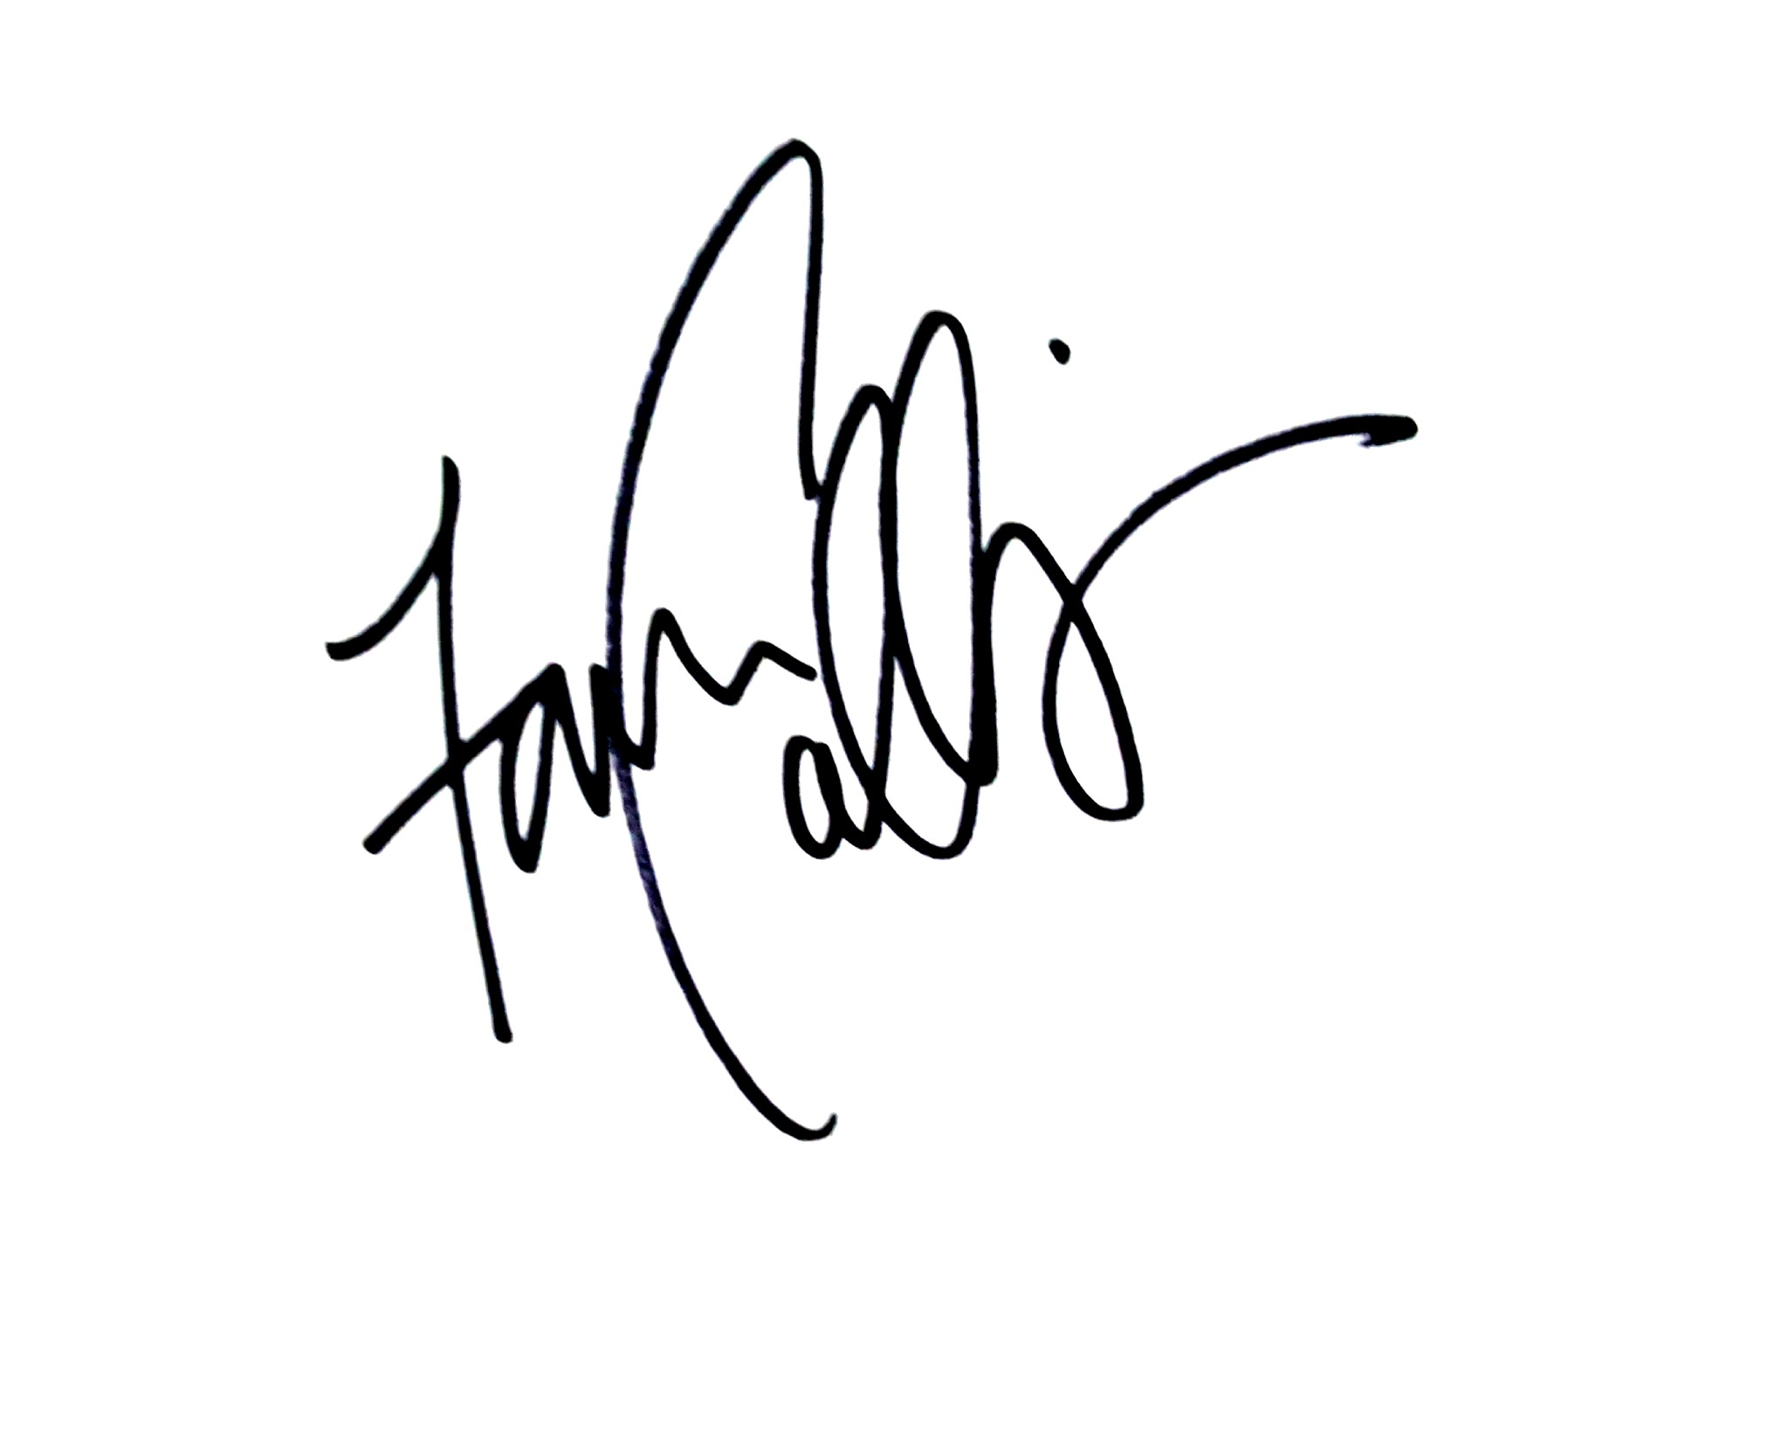
Faren Collins
Owner, Farever Art

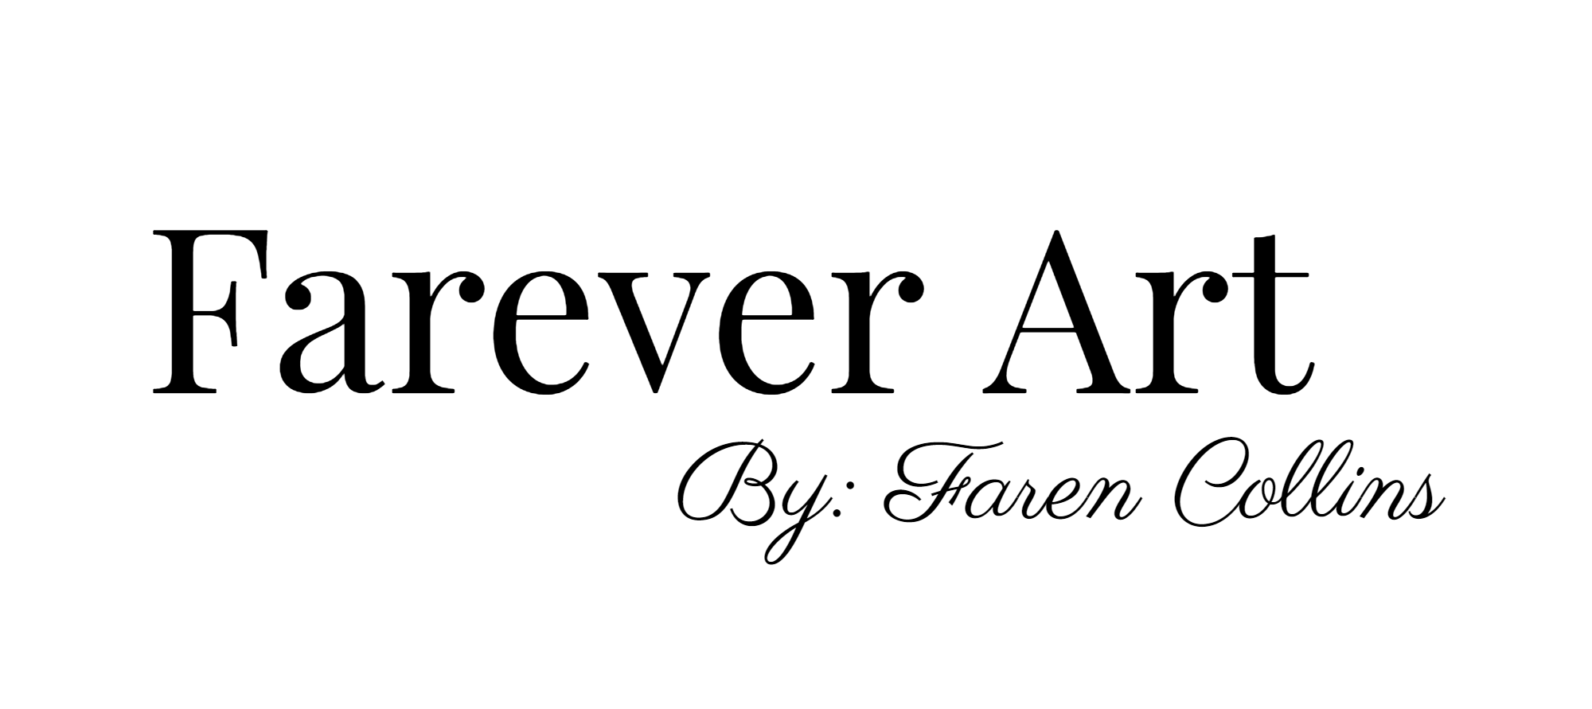

CLIENT INFORMATION

Name of Client: __________________________________________________
(First) (Last)
Address: _______________________________________________________
________________________________________________________
_________________________________________________________

Phone Number: __________________________________________________

Email: __________________________________________________________

DIMENSIONS

Currently I'm only offering to sizes for commissioned work.

__________ 7x10 (Standard)

MATERIALS

PAPER TYPE:
Arches Watercolor: Paper is mould made in France, with 100% cotton fiber content acid- free, PH - neutral, gelatin sized and air dried. Cold Pressed paper. Other presses available, prices may vary.

PAINTS:
Reeves: One of the most widely used painting mediums in the world for artists of all levels. Brilliant color for high quality pigment. Non Toxic.

DELIVERY:
If you are a Los Angeles local resident. I will hand deliver your piece for a $40 service charge. If you are out of state, shipping prices may vary.

NOTES :
If you have any questions, comments or concerns about commission. Please write in the box below.

FRAMING NOTES:
Framing is always optional. However, watercolor pieces need to be framed a very particular way to retain its beauty, luster and quality throughout the years. All watercolor pieces should framed in an acid free frame and matting with UV protected glass.

I do not offer framing at this time. However, I do suggest the following retailers for frames:
MICHAELS ARTS AND CRAFTS
FRAMES PLUS
BLICK ARTS SUPPLY
Any specialty Framing store can help.

